University of Engineering and Technology, Lahore
Name: Maria Abbas
Reg No: 2026(S) CYS_61
Department: Computer Engineering
Degree: Cyber security
Section: B
Assignment: PF Lab week 6
Date: 20 April 2026
CLO2

Lab Tasks
Local and Global variables
Task 1:
Local variable
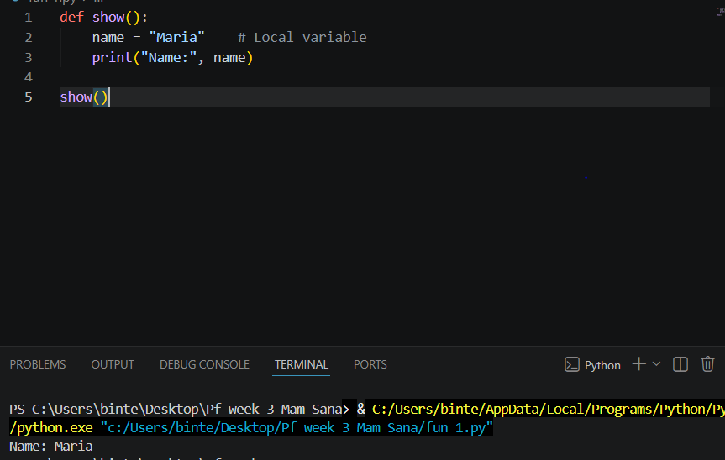
Global variable
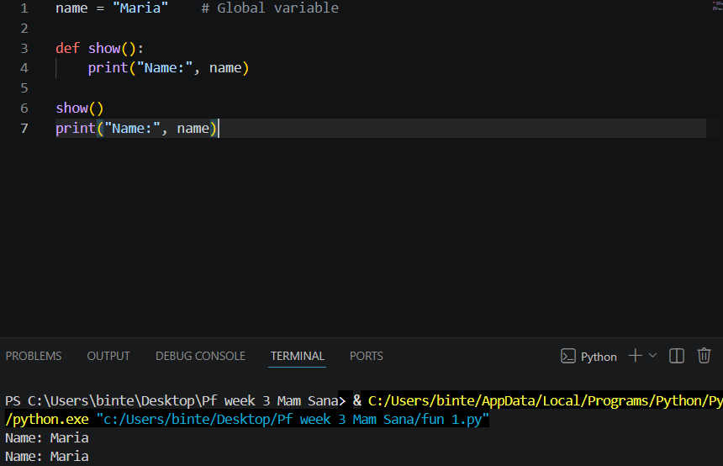
Task 2:
Local variables
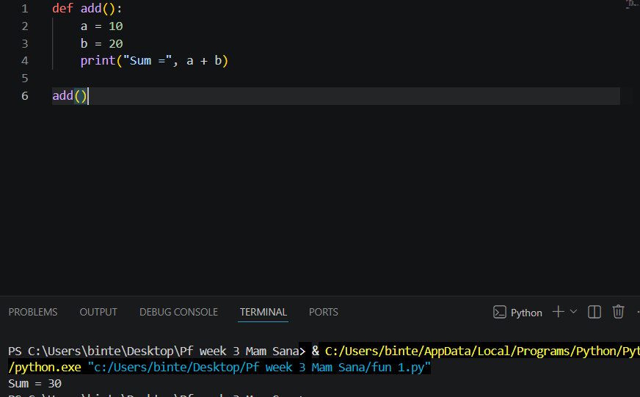

Global variables
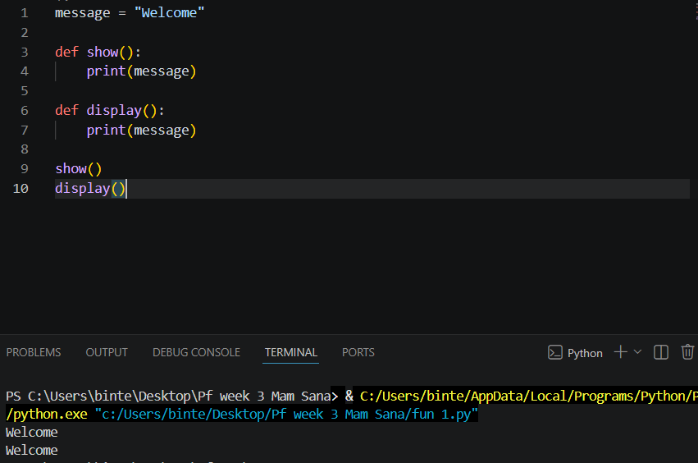
Task 3:
Local variables and global variables
